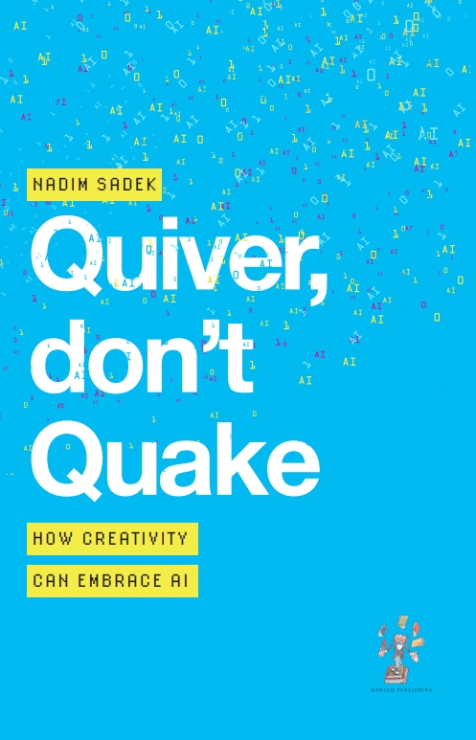
Quiver,
don't Quake

How Creativity can Embrace AI

Quiver,
don’t Quake

How Creativity can Embrace AI

Nadim Sadek





51 Northchurch Road,
London N1 4EE, United Kingdom

First published in Great Britain 2025
This edition published 2025

Copyright © Nadim Sadek 2025

The right of Nadim Sadek to be identified as the Author of this work has been asserted by him in accordance with the Copyright, Designs and Patents Act, 1988.

All rights reserved. No part of this publication may be reproduced, stored in a retrieval system, or transmitted in any form or by any means, electronic, mechanical, photocopying, recording or otherwise, without the prior per­mission of the publishers.

A catalogue record for this book is available from the British Library.

ISBN: 978-1-912914-89-0 (paperback)
ISBN: 978-1-912914-90-6 (ebook)
Typeset by Langscape
www.langscape.com

To all who glimmer in the dark,
may you now shimmer in the light.
And to Oisin, Sean, Shaefri and Searsha,
my glittering stars.

Contents
Prologue The Eight Billion Beat
Part I: Foundations
The Psychology of Creativity
The Psychology of AI
Interlude: Why we should quake
Part II: Practices
Collaborative Creativity
Creative Industries on the front foot
Beyond the Arts
Part III: Momentum
The New Creative Alliance
The Creative Classroom
Nations in the dance
Constructive Contradiction
Becoming a collaborative creator
The creative pulse of the world
The Whole Book In... (thank you, Claude)
This Book is a Living Example of Collaborative Creativity
Further Reading
About the author

